**Phase 2 of my project**

1. **The final Report**

About my project:

I am building an ecommerce website that let the user buy and sell various item especially electronic items.

Features:

* Major feature of my website starts from the login page where user can login with their username and password, they can also reset their password and they can sign up from there too.
* After logging into the main page, the user can see the whole website where we have inserted various buttons that include home, shop by category, Deals, Return& Order, Sell, Help& Contact and Logout.
* In the home menu all the items are listed, in the shop by category menu we put a dropdown menu where user can choose items by various categories, in the same way when user clicks on Deals button they can find the deals on various items, Return& Order includes those items which are refunded, again Sell button have those items that are sold out, also Help& Contact is for contacting the seller if they have any problem with the items and when they want to logout from the website they can simply click on logout button.

Tools and Technology:

We use Visual Studio Code to write all the codes of HTML, CSS and JavaScript for building our website. We also take some help from google and w3 school during our project.

Screenshot of website:

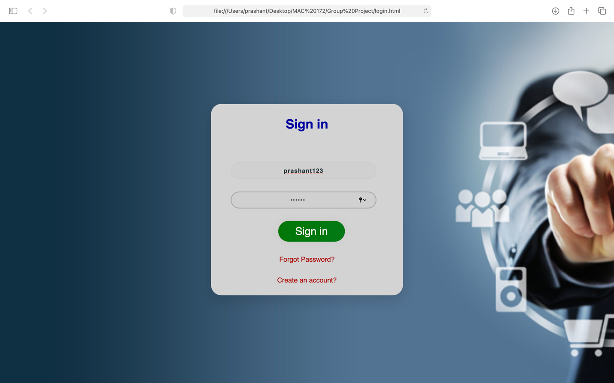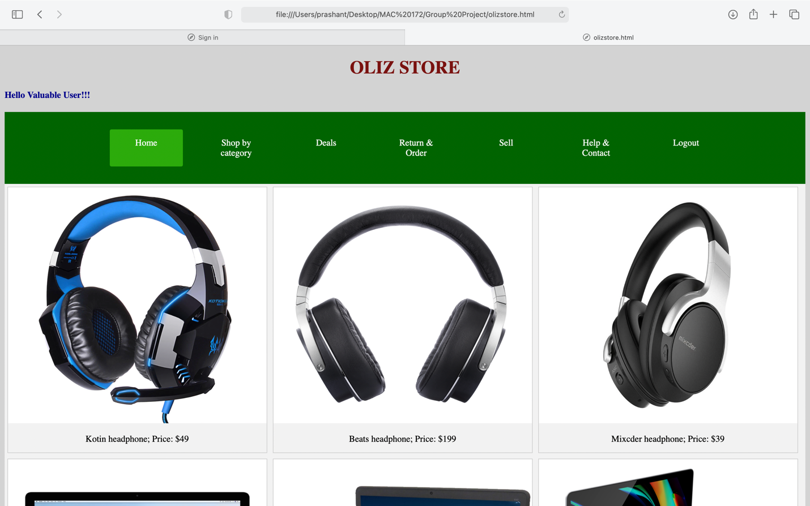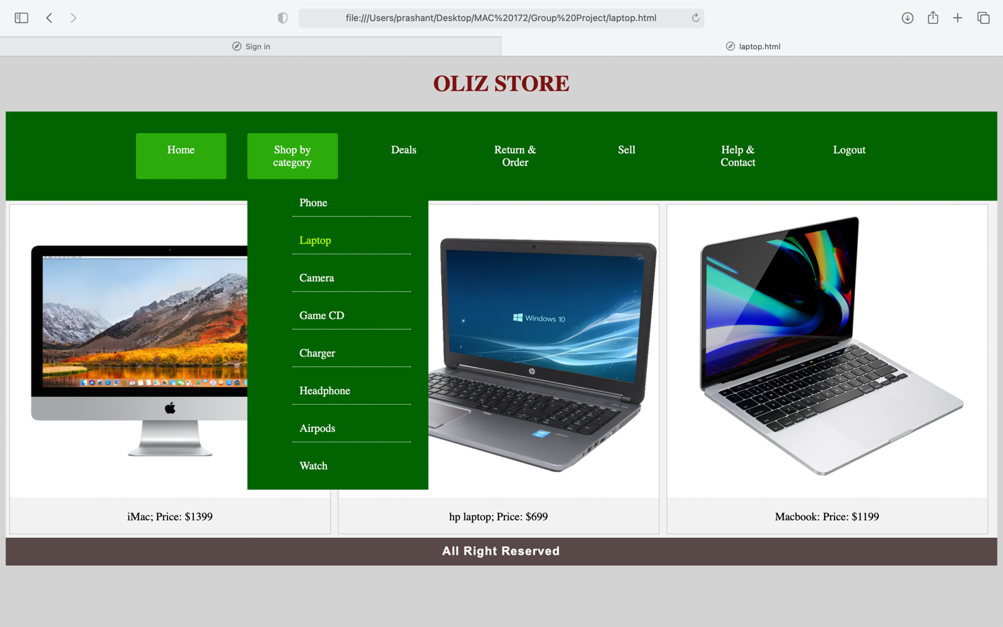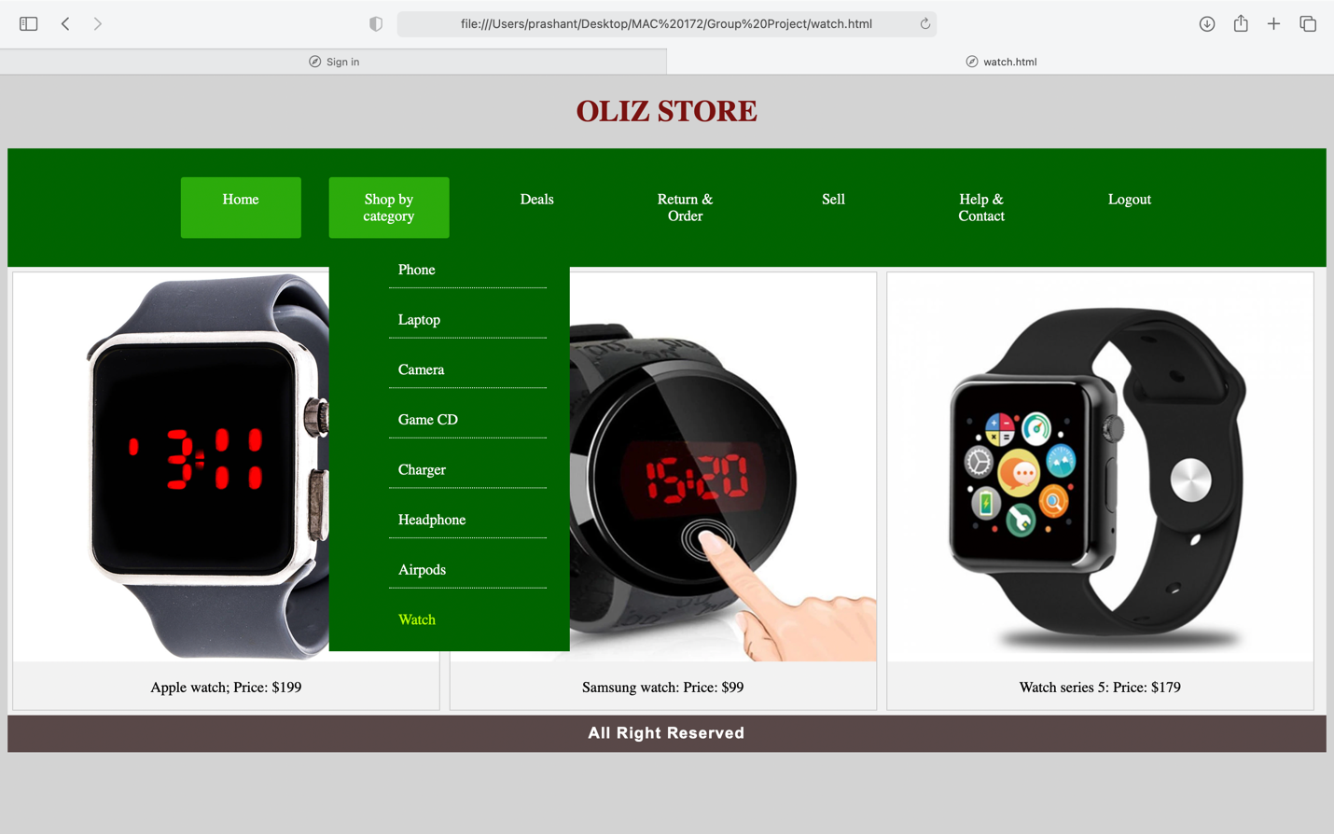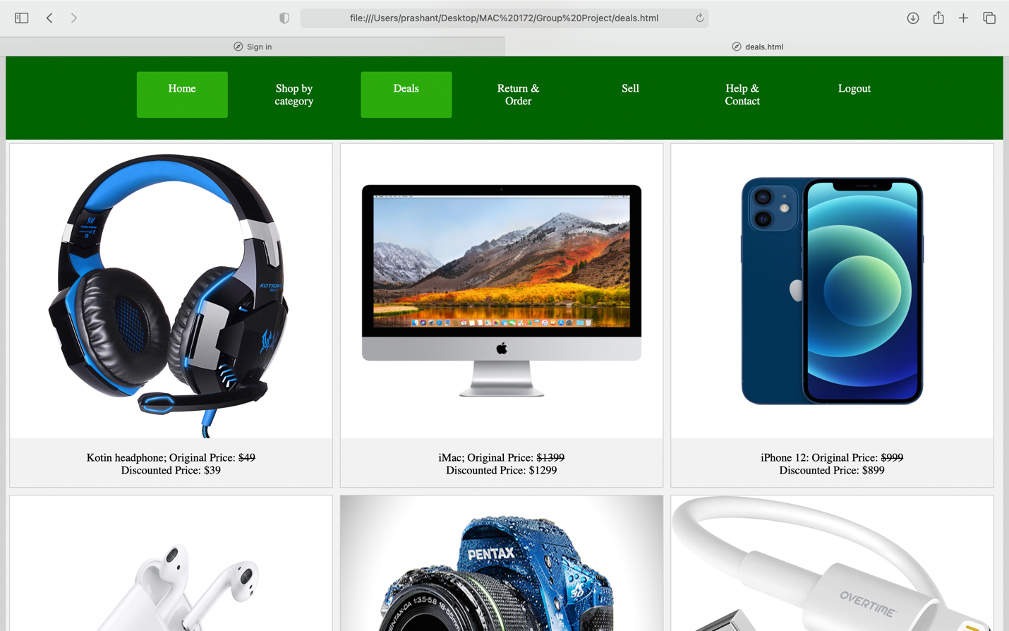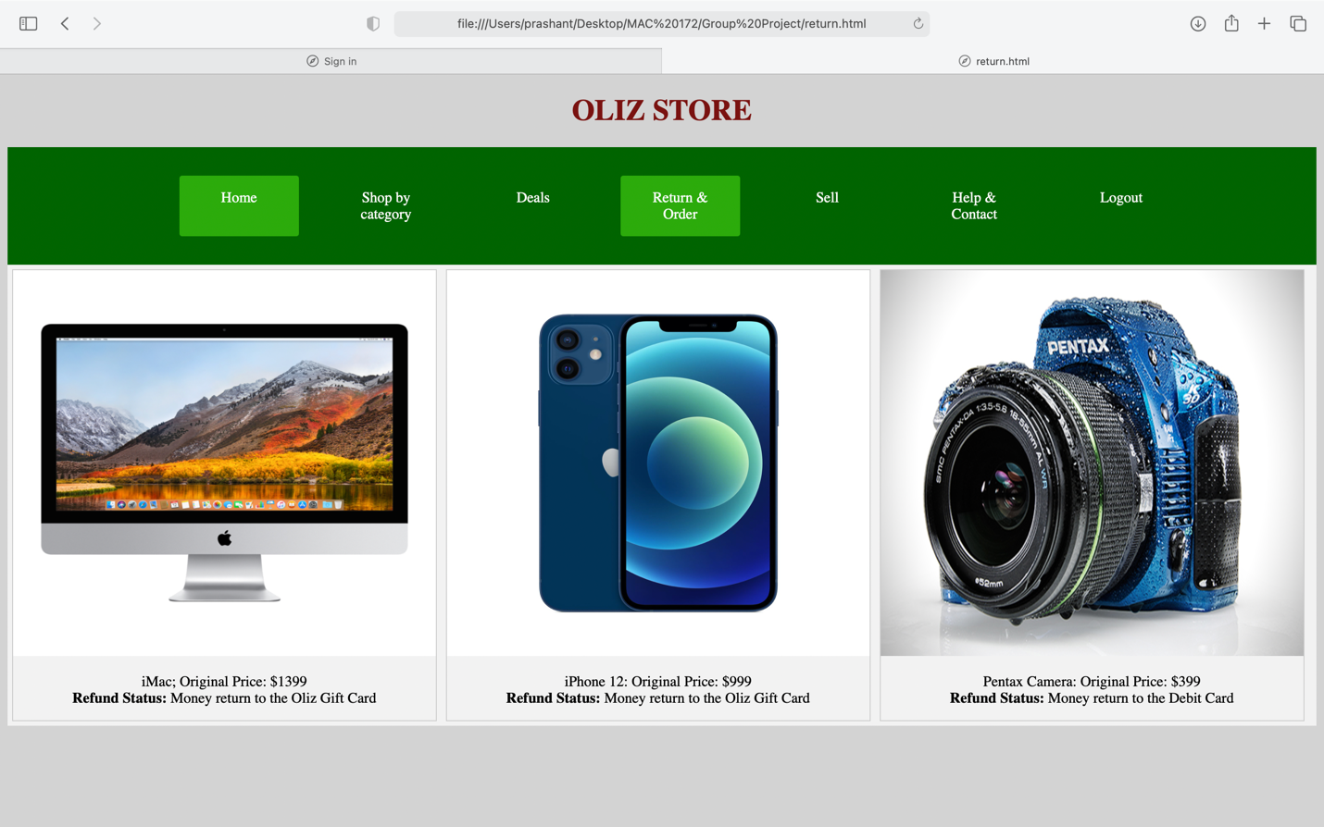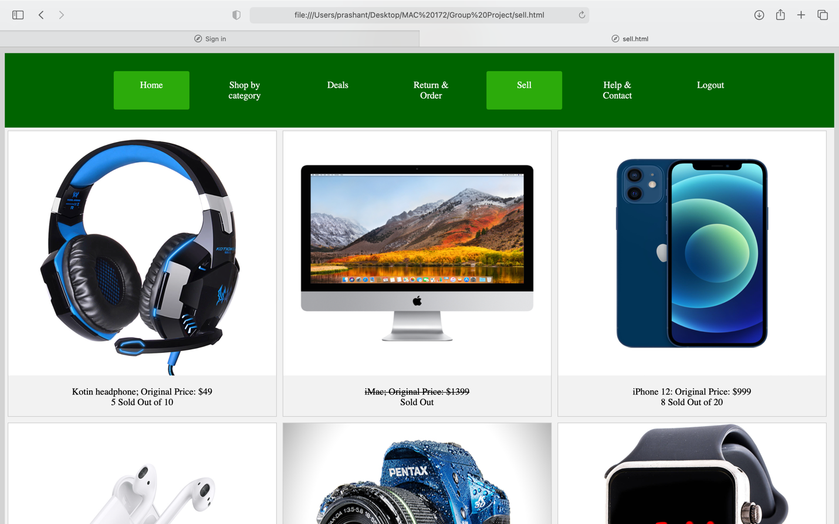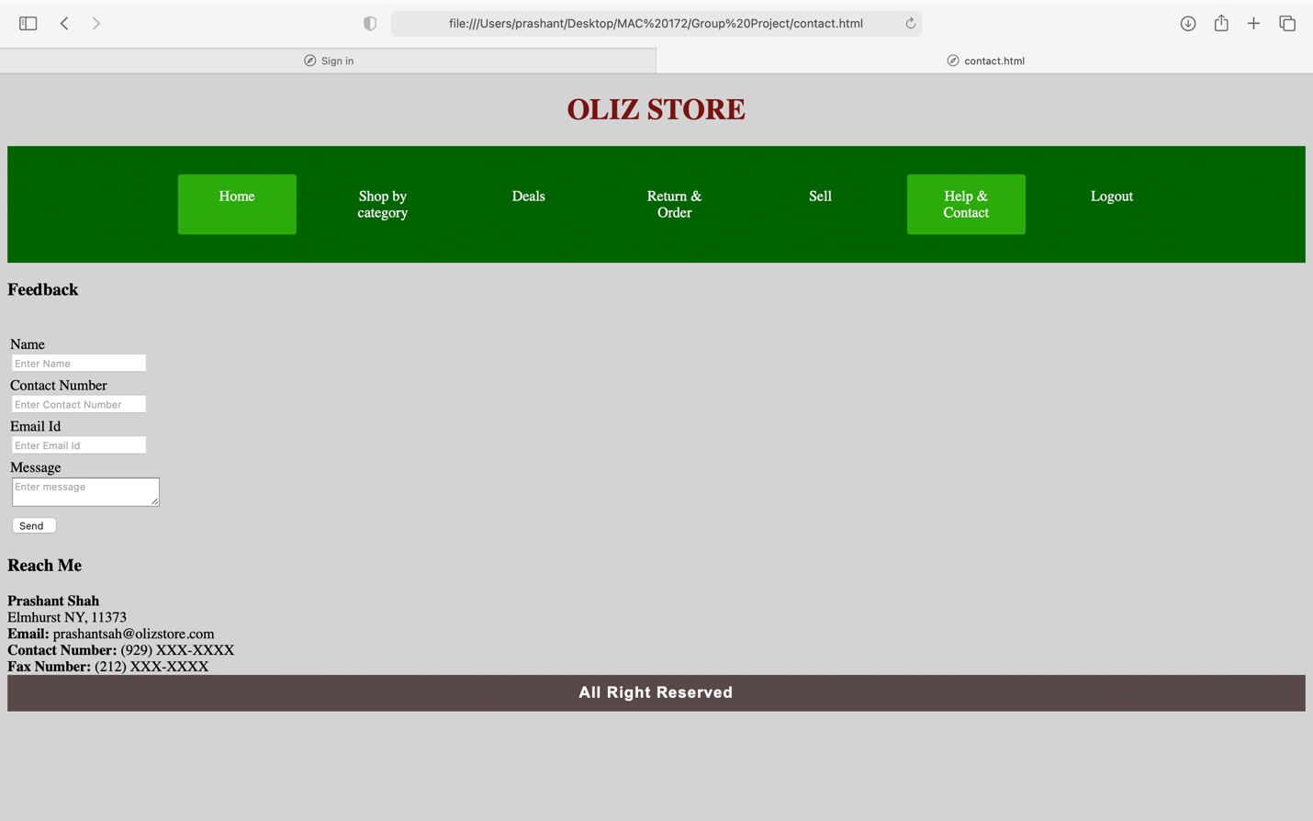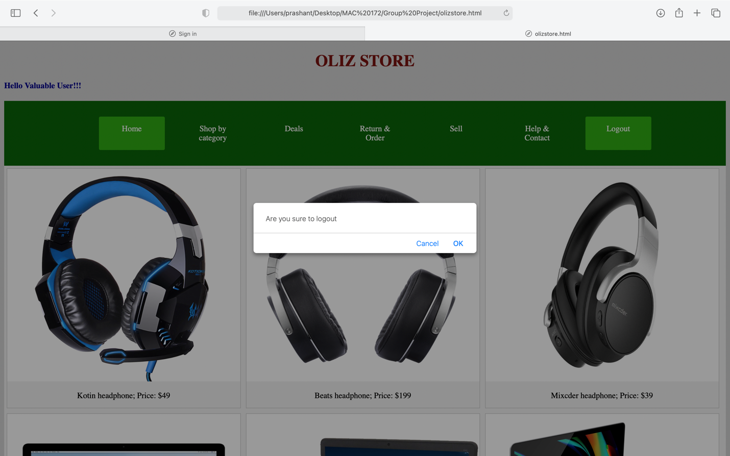

Reflection:

We learn a lot building this website, we learn how to implement the HTML, CSS and JavaScript which are taught in the class. We know what error can occur and how to overcome those errors. In future we are going to update this website when we learn the server site language and we are going to host this website with few improvements.

1. **Project Code**

I cannot put the Zip file in the word document so I would put that into a different file, and you can start with the login page which is the first file in the Zip folder and for login the username and passwords are:

Username- ps

Password – ps

Or

Username- prashant123

Password- sah456

1. 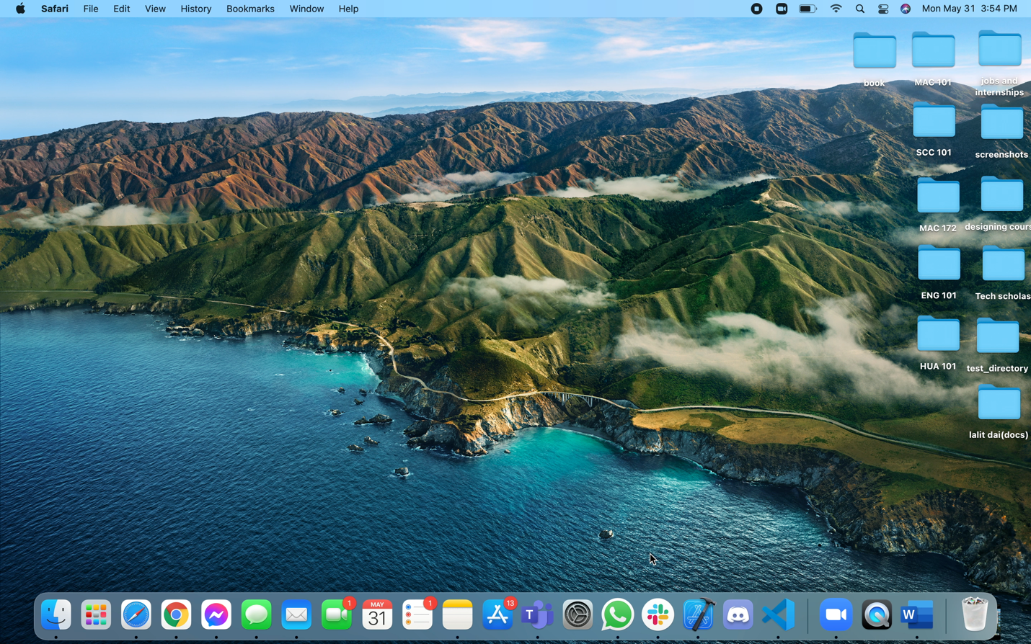**Video recording of my project**

This is the video recording of my project, hope you going to like it: